**A PROJECT REPORT ON**

**Online Automated Examination System**

**For Physically Handicapped Students Using (AI and ML)**

**BY**

**Ms . Akshata Shirwale**

**[34303]**

**IN PARTIAL FULFILLMENT OF**

**M.Sc. (Computer Science) Part I**

**Semester II**

**SIR PARASHURAMBHAU COLLEGE, PUNE**

**(2022-2023)**

Shikshana Prasaraka Mandali’s

**SIR PARASHURAMBHAU COLLEGE AUTONOMOUS**

TILAK ROAD, PUNE – 411 030.

Department of Computer Science

Certificate

This is to certify that Ms. **Akshata Dattatray Shirwale** has presented a project titled **Online Automated Examination System for Physically Handicapped Student using AI and Ml** in Elective Course (MCS12817)- Project as partial requirements fulfillment of M.Sc. (Computer Science) Part I Semester II.

Date: 17 / 05 / 2023

Head,

Teacher In-Charge Department of Computer Science

Internal Examiner External Examiner

**ACKNOWLEDGEMENT**

We would like to express our profound thanks to all those who helped in making this project a reality. Much needed moral support and encouragement was provided on numerous occasions by all teachers and fellow students.

We all are mostly thankful to our Head of the Department **Mr. Deepak Londe** sir, we are also especially grateful and to our teacher and project guide **Mrs . Rutuja Madiwale** mam for his time to time, much needed, valuable guidance. she has been available to help us whenever required. she has been our guiding star, guiding us through the right direction to make this project a success. Without his full support and cheerful encouragement, we would have not been able to complete the project in time. We are sincerely thankful to him.

**INDEX**

|  |  |  |
| --- | --- | --- |
| **SR.NO** | **TITLE** | **PAGE.NO** |
|  | INTRODUCTION | 5 |
|  | EXISTING SYSTEM | 6 |
|  | SCOPE OF WORK | 7 |
|  | FEASIBILITY STUDY | 9 |
|  | HARDWARE & SOFTWARE REQUIREMENT | 10 |
|  | FLOWCHART | 11 |
|  | ENTITY REALTIONSHIP (E-R) DIAGRAM | 13 |
|  | UML - DIAGRAMS | 14 |
|  | USER-INTERFACE DESIGN | 18 |
|  | TESTING AND IMPLEMENTATION PLAN | 24 |
|  | LIMITATIONS | 27 |
|  | DRAWBACKS | 29 |
|  | PROPOSED ENCHANCEMENT | 30 |
|  | BIBILOGRAPHY | 31 |

**INTRODUCTION**

* An online examination system is a digital platform that allows educational institutions, organizations, or individuals to conduct assessments and examinations electronically. It replaces the traditional pen-and-paper approach by utilizing internet connectivity and specialized software to deliver, and evaluate exams.
* Writing examination could be a challenging task for the persons with disabilities. Those with physically disable and visual impairment find it difficult to read questions and write answers.
* The Ministry mandates that the **“extra time”** should be referred to as **“compensatory time”.** Any person with benchmark disability and having limitation in writing exams is allowed to have a scribe/reader/lab assistant. But giving to much the **“compensatory time” & “extra time”** is not possible in real time examination, because is not flexible to both the student and teachers.
* Another scenario if students are absent if any reason that time examination are taken (like viva and internal type small examination) difficult to conducting for those students are physically disability or cerebral palsy. These students cannot attend lectures and examination regularly on time as per college and university rules .
* It also uses for many types of examination purpose like small exam which conducted on google forms. we can say that one type of replacement of examination which conducted on google form. Because when we use these type of forms faculties can not check that any malpractice and unfair was happening or not.
* Additionally, online examination systems generate valuable data and analytics. Institutions can analyse exam performance, identify trends, and gain insights.

**EXISTING SYSTEM**

The existing system of online examination generally consists of a web-based platform that allows students to take exams remotely using a computer or other internet-enabled device.

* **The system typically includes features such as:-**

1. **User authentication:** - The system verifies the identity of the user before allowing them to access the exam.
2. **Exam scheduling:**-The system allows instructors to schedule exams and set time limits for completion.
3. **Exam delivery:-** The system delivers the exam questions and any supporting materials to the student.
4. **Exam submission:-** The student submits their answers to the system for grading.
5. **Grading and feedback**:- The system grades the exam and provides feedback to the student.

* **Need For New System:-**
* While online examination systems there are also some challenges associated with them. One of the main challenges is ensuring the integrity of the exam. Cheating can be a significant problem in online exams, and preventing it requires careful design and monitoring of the system. Another challenge is ensuring that the system is accessible to allstudents, including those with Physical disabilities or limited access to technology. The main purpose of these system is a student with physical disabilities they need for more time and flexibility in the exam. They don’t go into any kind of discomforts in examination.
* Overall, the existing system of online examination has the potential to improve the efficiency and effectiveness of exams, but it requires careful design and implementation to ensure its success.
* Overall, a new online examination improve efficiency, enhance security, and provide a more flexible and convenient assessment experience for students and educators.

**SCOPE OF THE PROPOSED SYSTEM**

* The user has to register in system first, after that system allows user to login with their designated credentials . At the time of login system captures the photo of the candidate for check the valid student is give the exam or not.
* The system verifies the identity of the user before allowing them to access the exam. If information of student is valid then only student access the exam otherwise not.
* At the time of examination, the live face was detected by using face recognition technology and AI algorithms. System will verify image of user at every time of login and whole examination using face recognition technology. To verify an if any student cannot do any unfair or malpractice in the examination.
* At the time of exam, AI (artificial intelligence) tool was speaking a question for candidates , candidates don’t need to read the question , they have to give only the answers of those question , and AI tool is automatically record and check the answers is correct or not .
* Once the exam is completed, the system automatically evaluates scores, and generates results.
* We Consider providing extended time allowances or scheduled breaks for candidates with physical disabilities who may require additional time or extra time.
* We Provide audio-based examination to candidates with the visual impairments or other disabilities that affect reading or writing abilities.
* These features include remote proctoring, which monitors students during exams using video surveillance, audio recording, and AI algorithms to detect any suspicious behaviour or unauthorized activities.
* **Advantages of proposed system :-**
* Security of data.
* Fast results.
* Extended Time and Breaks for candidates.
* Reduced Physical Strain.
* Privacy and Independence.
* Accommodation for Specific Disabilities.
* Save the time.
* Time Efficiency.
* cost-effective option.
* Instant Results and Feedback.
* Enhanced Security Measures.
* Scalability.
* Improved Record-Keeping.
* It provides flexibility in terms of exam scheduling and location.
* Allowing students to take exams remotely at their convenience.
* reduce examines overhead.
* eliminate the need for paper, printing, and manual grading.
* Reduced Environmental Impact.

**FEASIBILITY STUDY**

A feasibility study for an online examination system is conducted to assess the viability and potential success of implementing such a system. It typically examines various aspects, including technical, economic, operational, and scheduling feasibility.

* **Technical Feasibility :-**

This included the study of function, performance and constraints that may affect the ability to achieve an acceptable system. For this feasibility study, we studied complete functionality to be provided in the system, as described in the System Requirement Specification (SRS), and checked if everything was possible using different type of frontend and backend platforms.

* **Economic Feasibility :-**

This is a very important aspect to be considered while developing a project. We decided the technology based on minimum possible cost factor. All hardware and software cost has to be borne by the organization. Overall, we have estimated that the benefits the organization is going to receive from the proposed system will surely overcome the initial costs and the later on running cost for system.

* **Operational Feasibility :-**

No doubt the proposed system is fully Automated based that is very user friendly and all inputs to be taken all self-explanatory even to a layman. Besides, a proper training has been conducted to let know the essence of the system to the users so that they feel comfortable with new system.

**HARDWARE AND SOFTWARE REQUIREMENT**

**Hardware requirements :-**

|  |  |
| --- | --- |
| Description | Required |
| Processor | I5 11th generation |
| Ram | 8 GB |
| Hard Disk | 1 TB |
| Monitor | 15 inches Colour Monitor |
| Keyboard | 122 Keys |
| Operating System | 64 Bit |

**Software requirements :-**

|  |  |
| --- | --- |
| Front-end | Html , CSS |
| Back-end | Python , Flask , SQLite |
| Models & Algorithms | Artificial Intelligence & Machine Learning   * NLP (Natural Language Processing) * Cosine Similarity algorithm |
| Platform | Windows 10 |

**FLOWCHART**

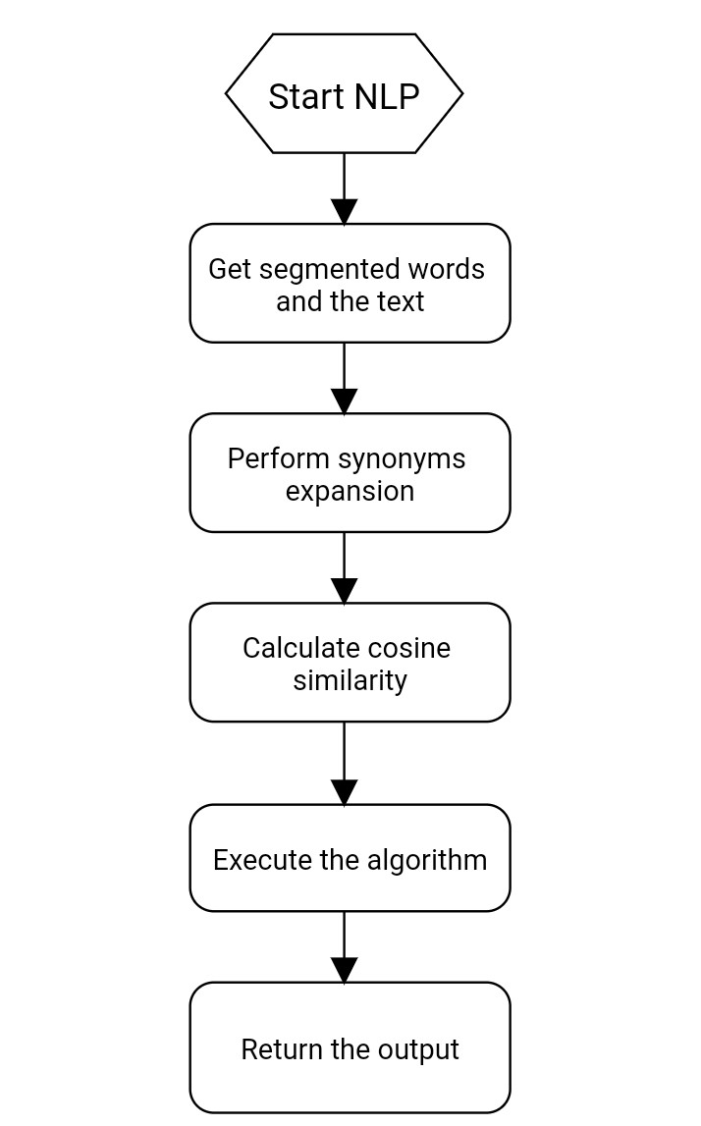

* **Process of NLP and Cosine Similarity algorithm**
* Text is input for Engine
* Engine produces Audio
* Audio is output for Engine
* Microphone is input for Speech
* Speech produces Text
* Text is input for cosine similarity algorithm
* cosine similarity algorithm compares Text with other Texts in the system
* Library is dependency for both Text-to-Speech and Speech-to-Text conversion
* Voice is property of Engine and can be selected for output

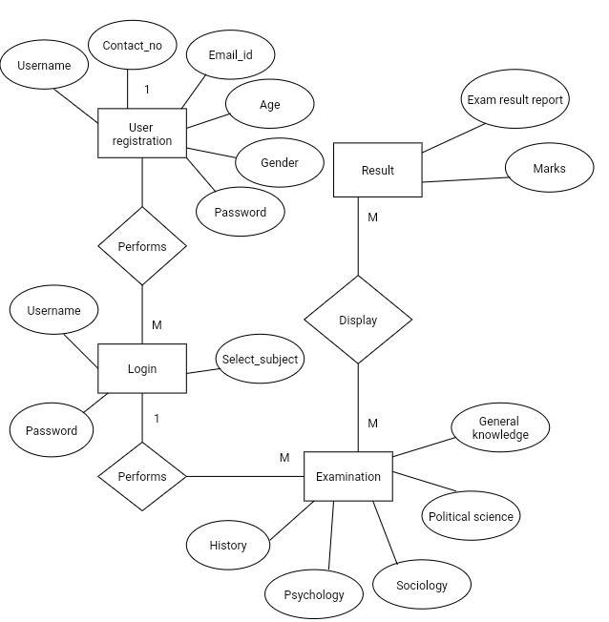**E-R DIAGRAM**

**class diagram**

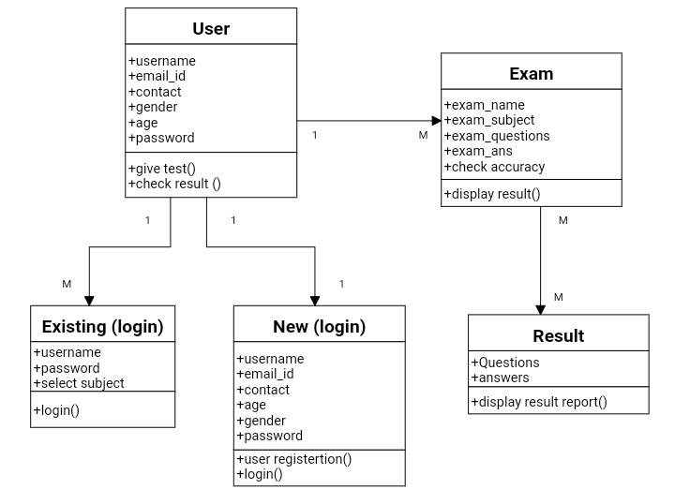

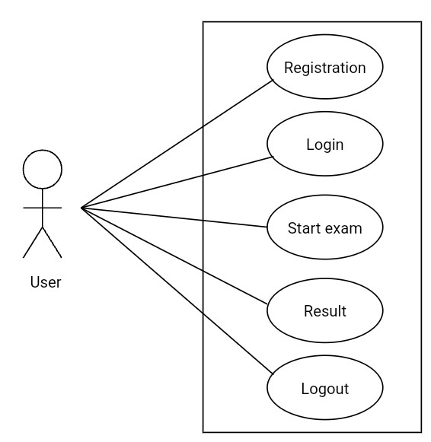**USECASE DIAGRAM**

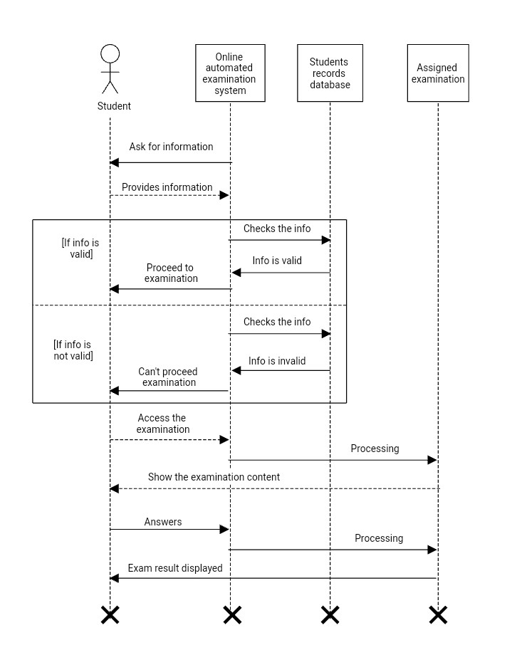**SEQUANCE DIAGRAM**

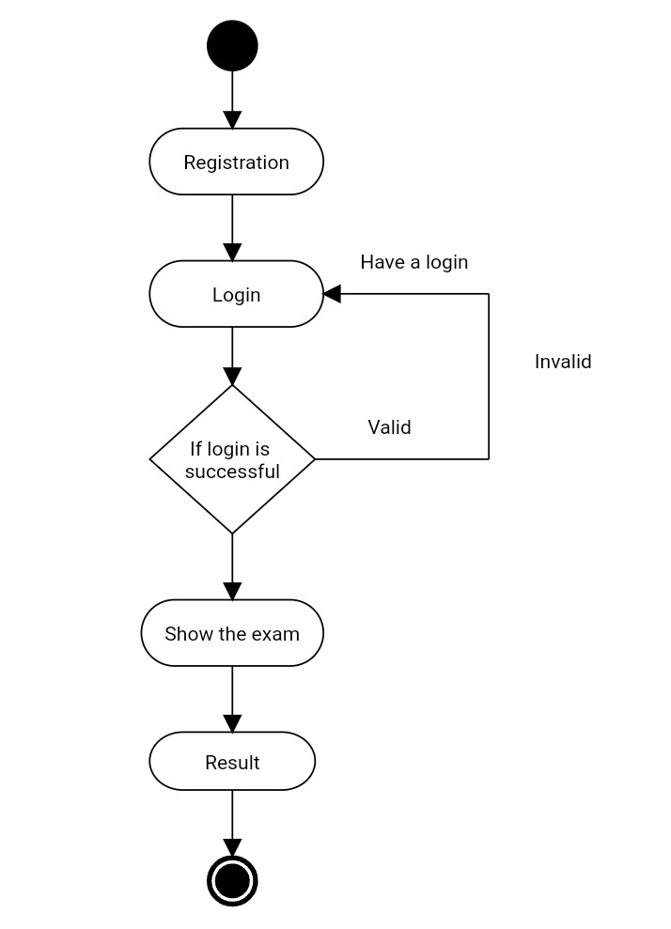**ACTIVITY DIAGRAM**

**USER INTERFACE DESIGN**

(Menus , Input screens , Reports)

**Home page**

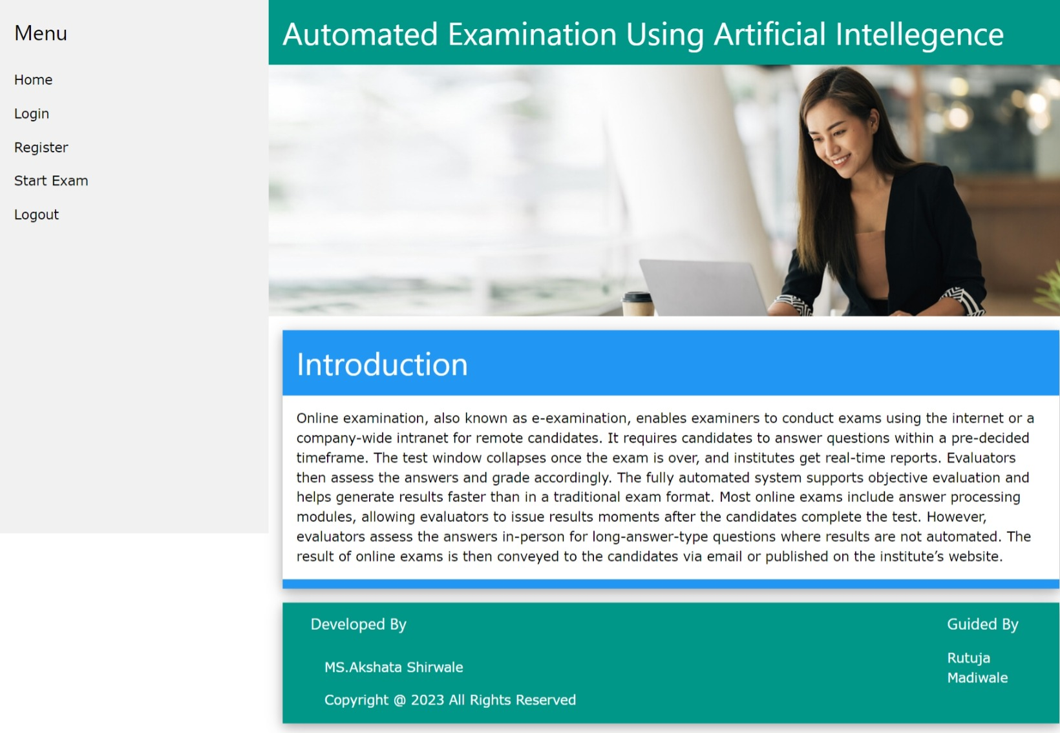

**Registration page**

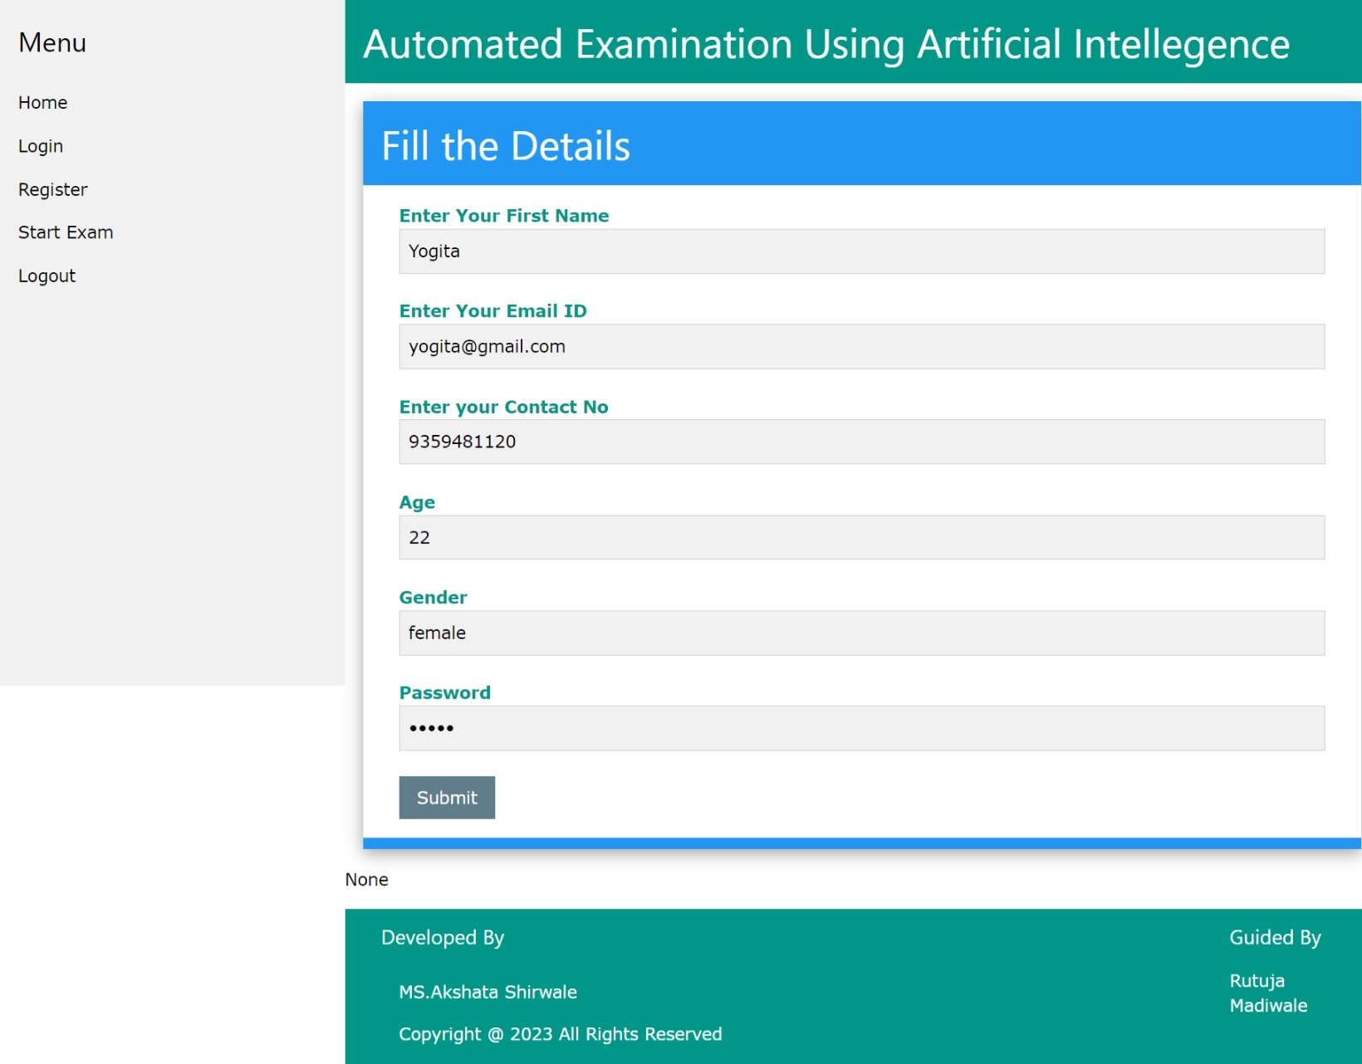

**Pre-login page**

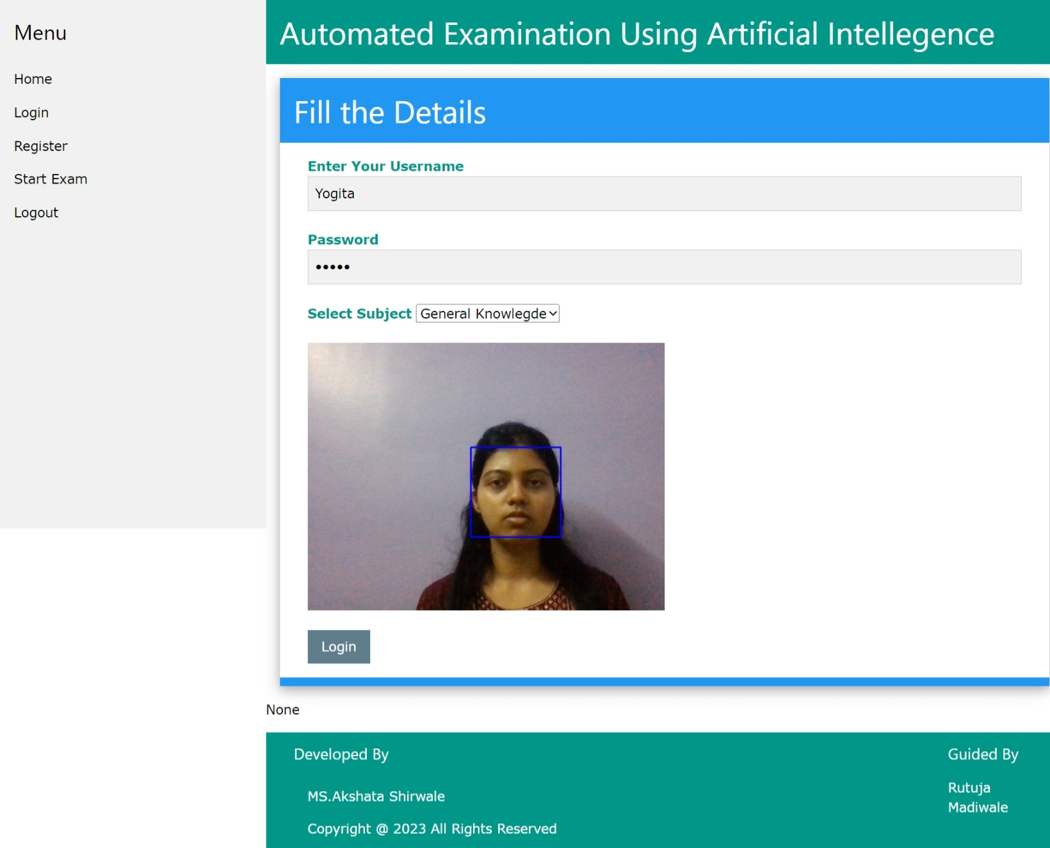

**Login page**

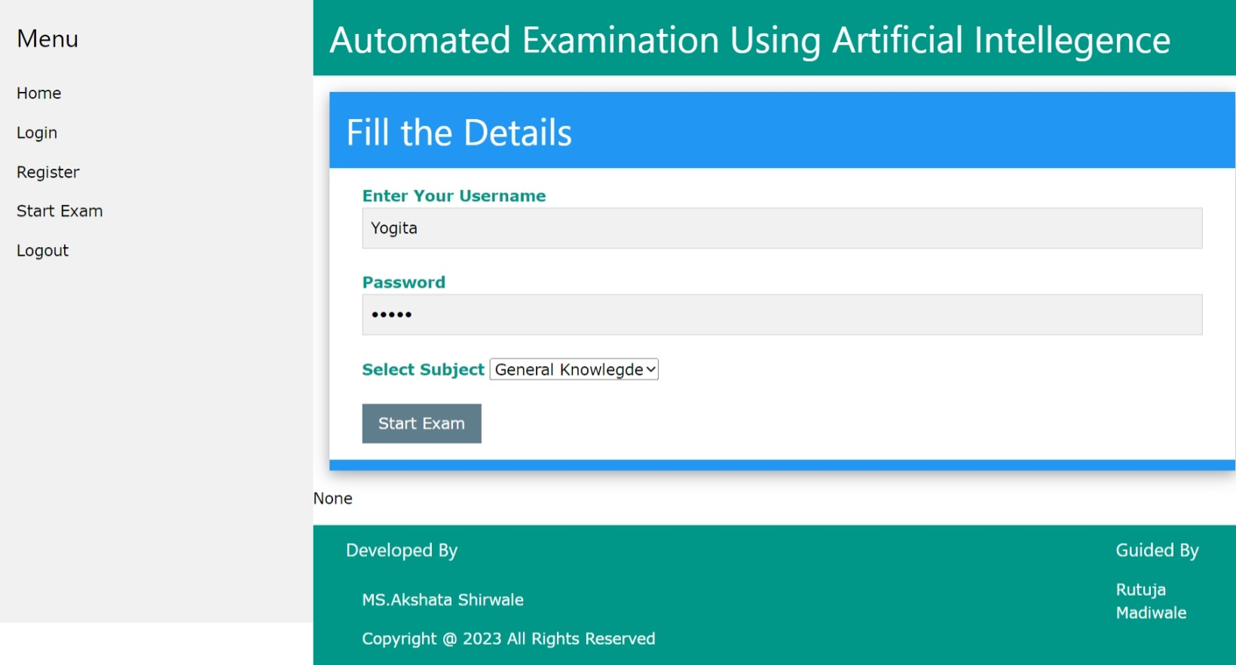

**Start Exam**

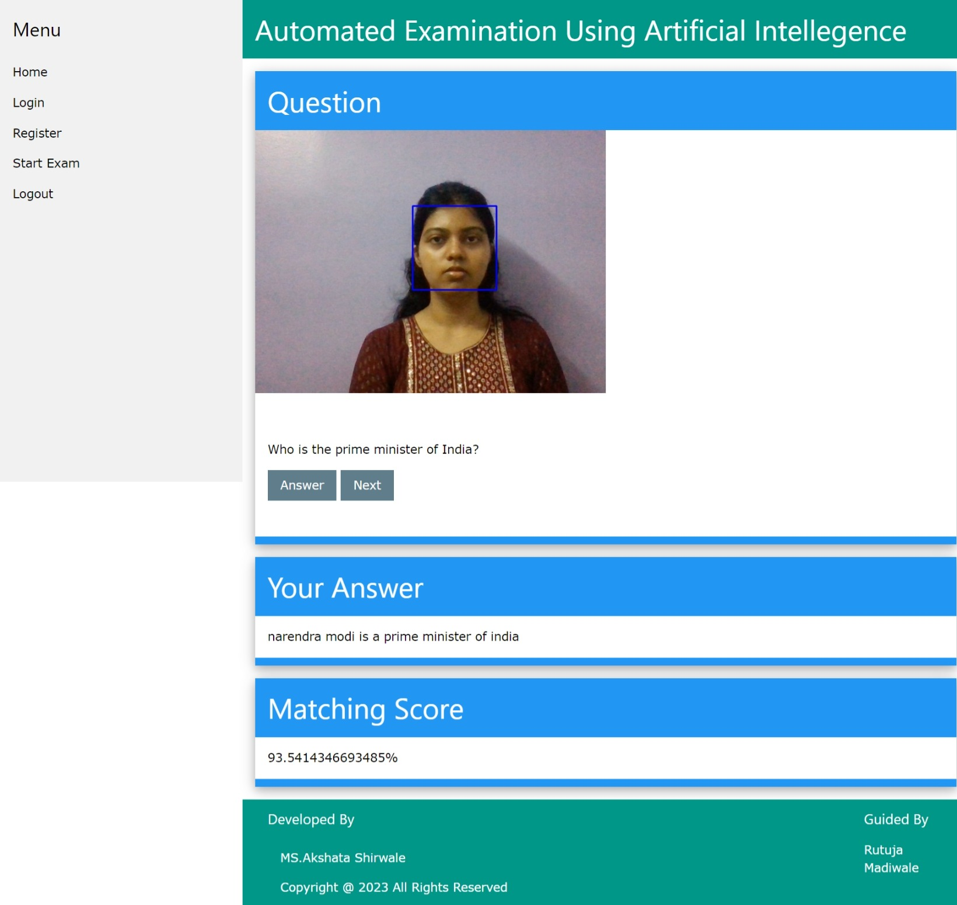

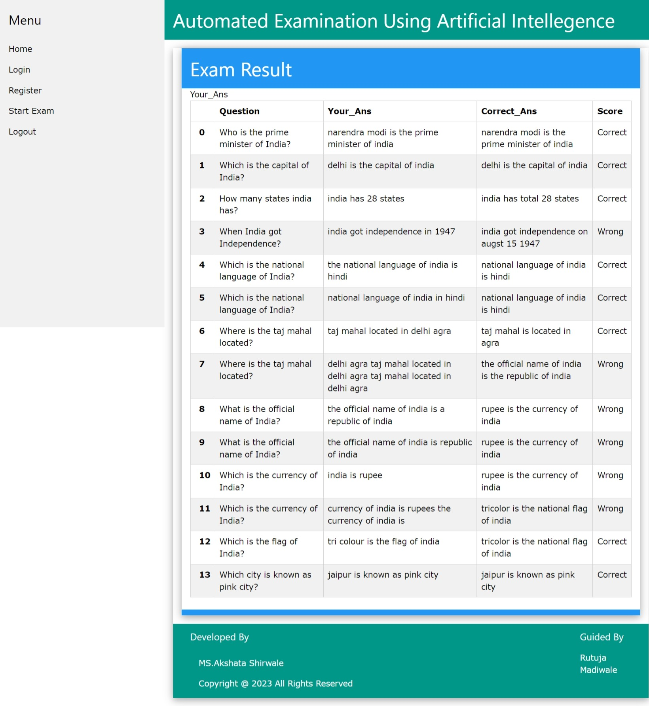**Result**

**TESTING AND IMPLEMENTATION PLAN**

|  |  |  |  |  |
| --- | --- | --- | --- | --- |
| **Test Case Description** | **Input** | **Expected Output** | **Actual output** | **Pass/Fail** |
| Valid Registered Credentials | Enter the valid Credentials username, email id, contact no, age, gender, password and Click to the ‘registered' button. | User successfully Registered | User successfully Registered | Pass |
| Invalid Registered Credentials | Enter the invalid Credentials username, email id, contact no, age, gender, password and Click to the 'registered' button. | Display error message: " User has been already register " | Display error message: " User has been already register " | pass |
| For checking Empty fields | Don’t Enter Credentials in given fields like a username, email id, contact no, age, gender, password and Click to the 'registered' button. | Display warning message: " User has to be field out the details " | Display warning message: " User has to be field out the details " | pass |
| Valid Login Credentials | Enter the valid Credentials username, password, select subject and Click to the ‘login' button. | User successfully logged in | User successfully logged in | pass |
| Invalid Login Credentials | Enter the invalid Credentials username, password, select subject and Click to the ‘login' button. | Display error message: " Invalid Credentials Please try again. " | Display error message: " Invalid Credentials Please try again. " | pass |
| Start Exam Without Login | User Access Exam page  Without login | User Redirect to login page | User Redirect to login page | pass |
| Select Exam and Start with login | Login with valid credentials and select subject and click here to 'Start Exam' button | Exam starts | Exam starts | pass |
| Submit Exam Without Answering Any Questions | Complete the exam and Click 'Submit' button | Display error message: "No answers submitted or unknow error occurred " | Display error message: "No answers submitted or unknow error occurred " | pass |
| Submit Exam with Partially Answered Questions | Answer some of the exam questions, and complete the exam Click 'Submit' button | Exam submitted with partially answered questions | Exam submitted with partially answered questions | pass |
| Submit Exam with All Questions Answered | Answer all exam questions, and complete the exam Click 'Submit' button | Exam submitted with all questions answered | Exam submitted with all questions answered | pass |
| Checking for AI Tool Is Speaking Questions or Not | User has to verify internet is on or not and good internet or network connectivity. | AI tool speak the questions for the user | AI tool speak the questions for the user | pass |
| Checking For Camera Is On At Time Of Exam | User allows camera at time of examination compulsory. | Camera will be detected  i) face is found  ii) face is not Found  iii) Multiple face is found | Camera will be detected  i) face is found  ii) face is not Found  iii) Multiple face is found | pass |
| Checking for the Microphone Is on or not | User allows microphone at time of examination compulsory to listen the answers. | Microphone is on and listen the answer or content which user will speak. | Microphone is on and listen the answer or content which user will speak. | pass |
| Checking for the Accuracy Is on or not | User has to answer the question after that accuracy will be detected. | Accuracy is 100% detected. | Accuracy is 100% detected. | pass |
| View Exam Results | Login with valid credentials and Select Exam and Click 'View Results' button. | Display exam results | Display exam results | pass |
| Access Exam Results without Taking the Exam | Login with valid credentials and directly access exam results page. | Redirect to exam selection page | Redirect to exam selection page | pass |
| Logout | Click 'Logout' button | User Successful logout | User Successful logout | pass |

**LIMITATIONS**

* **Technical Issues :-** Online examination systems really heavily on technology, and technical issues such as server downtime, connectivity problems, or software glitches can disrupt the examination process and cause inconvenience to students and teachers.
* **Cheating Concerns :-** Remote proctoring methods used in online exams may not be fool proof and can be susceptible to cheating. It can be challenging to monitor every student effectively and ensure the integrity of the exam environment.
* **Infrastructure Requirements :-** Conducting online exams requires a stable internet connection, suitable devices, and compatible browsers. Students from low-income areas or regions with limited infrastructure may face difficulties in accessing and participating in online exams.
* **Limited Interaction :-** Online exams lack the face-to-face interaction that traditional exams provide. Students may miss out on the opportunity to clarify doubts, seek immediate feedback, or engage in discussions with teachers and peers.
* **Impersonation and Identity Verification :**- Verifying the identity of students in an online setting can be challenging, as it may be difficult to ensure that the person taking the exam is indeed the registered student. Impersonation or identity fraud can compromise the fairness of the examination process.
* **Technological Literacy :**- Students and teachers need to be familiar with the online examination system and comfortable using technology. In some cases, individuals with limited technological skills may face difficulties navigating the system.
* **Accessibility Challenges :-**  Online examination systems may present accessibility challenges for students with disabilities. It's important to ensure that the system is designed and developed with accessibility standards in mind to accommodate all students.
* **Dependence on Internet Connectivity** :- Online exams require a stable and reliable internet connection. In areas with poor internet connectivity or during situations where internet access is disrupted, students may face difficulties in completing the exams on time.
* **Test Security Concerns** :- Protecting the exam content from being leaked or shared before or during the exam can be a significant challenge. It's crucial to implement robust security measures to safeguard the integrity of the exam questions and prevent unauthorized access.
* **Limited environment control :-** Unlike traditional exams held in controlled physical environments, online exams cannot completely control the testing environment. Students may have access to external resources, textbooks, or assistance from others, making it difficult to ensure a fair assessment.
* **Limited time for critical thinking :-** Online exams often have time constraints, limiting students' ability to engage in critical thinking and comprehensive problem-solving. Students may feel rushed and be unable to fully demonstrate their knowledge and skills.
* **Potential for system overload :**- During peak times, when a large number of students are simultaneously accessing the online examination system, the servers may experience high loads and slow response times, affecting the overall user experience.

**DRAWBACKS**

1. Dependency on internet.
2. Dependency on power supply.
3. Dependency on camera and microphone.
4. Server failure.
5. Lack of Personalized Attention.
6. System Compatibility Issues.
7. Internet Bandwidth Limitations.
8. Limited Use of Hands-On Assessments.
9. Cost of Implementation.

10. Technical issues.

**PROPOSED ENHANCEMENT**

* **Secure Authentication:-** Implement a robust and secure authentication process to ensure that only authorized individuals can access the examination system. This can include multi-factor authentication, such as using a combination of passwords, biometrics, and one-time passcodes.
* **Flexible Question Types:-** Expand the range of question types beyond multiple-choice questions to include interactive elements like drag and drop, matching, and simulations. This can provide a more comprehensive assessment of the students' knowledge and skills.
* **Real-time Feedback:-** Provide instant feedback to students upon completing an exam. This feedback can include correct answers, explanations, and performance analytics to help students identify their strengths and weaknesses, allowing them to focus on areas that require improvement.
* **Accessibility Features:-** Ensure the online examination system is accessible to all students, including those with disabilities. Implement features such as screen readers, colour contrast options, keyboard navigation, and alternative text for images to accommodate different accessibility needs.
* **Mobile Compatibility:-** Optimize the online examination system for mobile devices, allowing students to take exams using smartphones and tablets. This enhances flexibility and convenience, enabling students to take exams from any location with internet access.
* **System Scalability:-** Design the system to handle a large number of concurrent users and examinations without compromising performance or security. Scalability is crucial to accommodate a growing user base and prevent system overload during peak times.

**BIBLIOGRAPHY**

* [www.youtube.com](http://www.youtube.com)
* www.google.com
* S. Mittal and N. Singhal. (2019). A Comparative Study of Online Examination System. International Journal of Innovative Technology and Exploring Engineering, 8(7), 2345-2350.
* A. Kaur and K. Bansal. (2018). Design and Development of an Online Examination System. International Journal of Engineering and Technology, 7(3.25), 107-112.
* S. R. Shinde and D. R. Patil. (2017). Design and Development of Online Examination System. International Journal of Computer Applications, 170(4), 37-41.
* A. Jain and A. Sharma. (2018). A Review on E-Examination System and Its Advantages. International Journal of Computer Applications, 180(21), 25-28.
* S. K. Kulkarni, S. R. Mantha, and S. R. Kulkarni. (2016). Design and Implementation of Online Examination System. International Journal of Innovative Research in Science, Engineering and Technology, 5(3), 3440-3446.
* A. A. Khan, A. Farooqui, and S. A. Khan. (2020). A Study on Online Examination System and Security Measures. International Journal of Innovative Research in Computer Science & Technology, 8(2), 120-125.